Task

**Course**: Artificial Intelligence

(Machine Learning & Deep Learning)

Name: Abbas Shafi

Father Name: Dr Muhammad Shafi

Week: 03

Submitted to: Sir Syed Nazir Afridi



National Vocational & Technical Training Commission

National Center For Big Data & Cloud Computing

University of Engineering & Technology

Peshawar

# LAB NO. 1 DICTIONARY,SETS,TUPPLE

**Python Programming**

# Introduction:

Python programming is general purpose object oriented dynamic programming language used mainly in AI, ML, DL and data science. This language is known for their easiness and high level language. Contain large number of libraries through which programmer can easily handle tasks.

**Tool used**:

* Jupyter Notebook
* Annaconda

**Task 1**: Write a program to create dictionary of urdu word with their English translation provide user with an option to look it up

# Code:

dict={"darwaza":"door","bijli":"electricity","basta":"bag","karkhana":"industry","ustaad":"te acher"}

print(dict.keys())

a=input("enter your word from above present") print(dict[a])

# Output:



**Task 2:**Write a program to take 6 numbers from user and display it as unique number as once

# Code:

n1=int(input("num1 ")) n2=int(input("num2 ")) n3=int(input("num3 ")) n4=int(input("num4 ")) n5=int(input("num5 ")) n6=int(input("num6 ")) s={n1,n2,n3,n4,n5,n6} print(s)

# Output:

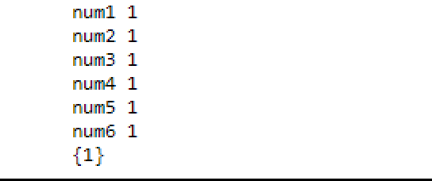

**Task 3:** Can we have a set of 18 int and 18 string as value in it.

# Code:

**set1={1,2,3,4,5,6,7,8,9,10,11,12,13,14,15,16,17,18} set2={"a","b","c","d","e","f","g","h","i","j","k","l","m","n","o","p","q","r"}**

# print(set1.union(set2)) Output:



**Task 4:** s={} what is the type of s

# Code:

s={} what is the type of s

# Output:

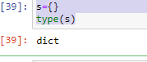

**Task 5:** What will be the length of following set s s.add(20)

s.add(200) s.add(“20”)

# Code:

num1=int(input("enetre num1 ")) num2=int(input("enter num2 ")) average=(num1+num2)/2 print("Average =",average) **Output:**

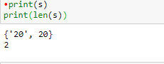

# Conclusion:

In this lab we learned dictionaries,tuple,sets of python programming and how to implement them. All the tasks were performed and submitted to the instructor.

# LAB NO. 2 Functions

**Task 1**: Write a program to greet person using function

# Code:

#Write a program to greet person using function def greet(name):

st="Hello" print(st,name)

st=input("name ") greet(st)

# Output:



**Task 2:** Write an program to find number is even or odd using function

# Code:

#Write an program to find number is even or odd using function def evenodd(n):

if(n%2==0):

print(n, "even number") else:

print("odd") n=int(input("entre number")) evenodd(n)

# Output:

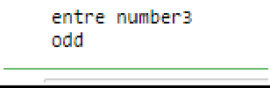

**Task 3:** Write a program to find greater of three number

# Code:

def greatnumber(a,b,c): if(a>b and a>c):

print("num 1 is greater ",a) elif(b>a and b>c):

print("num2 is greater ",b) else:

print("num3 is greater ",c) n1=int(input("num1 "))

n2=int(input("num2 ")) n3=int(input("num3 ")) greatnumber(n1,n2,n3) **Output:**

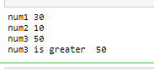

**Task 4:** A program to convert celcius into Fahrenheit

# Code:

def converttempt(cel): f=(c*9/5)+32 print("Fahrenheit =",f)

c=int(input("enter celcius")) converttempt(c)

# Output:

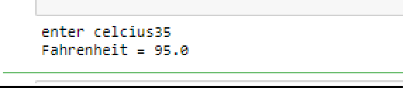

**Task 5:** A program to calculate factorial of number

# Code:

def fact(n):

return 1 if (n==1 or n==0) else n * fact(n - 1);

n=int(input("enter number")) print("Factorial of",n,"is",) fact(n)

# Output:

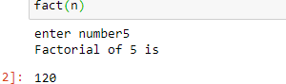

**Conclusion:**

In this lab we learned functions in python programming and how to implement them. All the tasks were performed and submitted to the instructor.